

Hands on Learning

In the School Garden

This workshop will increase teachers' awareness of ways literacy, maths, science and geography learning outcomes can be met in the school garden, bush patch or even the weedy edges of the playground. Participants will develop an understanding of the benefits of growing and eating fresh vegies, recycling organic waste to make healthy soil, have the opportunity to earn a Licence to Care for Earthworms (a hit with Stage 2 and 3 students) and share other useful resources.

|  |
| --- |
| Hands-On Learning in the School Garden |
| **Focus Overview** |
| This workshop will increase teachers' awareness of ways literacy, maths, science and geography learning outcomes can be met in the school garden, bush patch or even the weedy edges of the playground. Participants will develop an understanding of the benefits of growing and eating fresh vegies, recycling organic waste to make healthy soil, have the opportunity to earn a Licence to Care for Earthworms (a hit with Stage 2 and 3 students) and share other useful resources. |

|  |
| --- |
| **Key Message - composting creates healthy soil –> healthy plants –> healthy people** |
| **Worms 101** (a simple acrostic)  **W**orms and Waste – their needs, anatomy, species, threats  **O**rganic matter – anything that was once alive and growing  **R**ecyclers – the humble worm is one of nature's best recyclers  **M**enu – variety of food, anything that was once alive, pH etc  **S**ustainability – living in ways that can go on forever, food cycles. |

|  |
| --- |
| **A.D.A.M. (another acrostic)** |
| **Aliveness** - Compost is a living system; microorganisms and bacteria do all the decomposing  **Diversity** - Make sure the materials you add to your compost are varied.  This will bring a variety of nutrients, minerals and microbes to your compost  **Air** - Compost needs air to stay alive.  Make sure you regularly turn or aerate your compost  **Moisture** - Keep the compost moist, a dry compost will not decompose |

|  |
| --- |
| **Resources (There Are So Many!)** |
| * Down to Earth - An Earth Works Learners Guide (Department of Environment & Conservation 2004) - Kariong Eco Garden has some copies ($5 donation) * Eat Your Garden - Organic Gardening for Home & Schools (Leonie Shanahan 2010) * The Mechanics of Organics (Kellie Bollard, 2011) * Permaculture GARDENS - sow, grow, care, share (Kellie Bollard, 2012) * Let worms wriggle into your life (Kariong Eco Garden, 2014) * A guide to Composting and Worm Farming (Stephanie Medway, Gosford Council, 2013) |

|  |
| --- |
| * If you didn't eat your greens.. a practical guide for managing green waste in schools (Peter Carroll, SCRAP 1999) * Outdoor Classrooms - a handbook for school gardens (Carolyn Nuttall and Janet Millington, 2008) * http://www.rumbalara-e.schools.nsw.edu.au/documents/230888/231169/teachers_notes___natures_recyclers.pdf * <http://www.kitchengardens.det.nsw.edu.au/kg/01_teachers/index.htm> * https://www.organicgardener.com.au/blogs/teachers-get-help-organic-gardens * http://www.abc.net.au/abcforkids/video/show.htm?show=DIRTGIRLWORLD * www.gardenate.com [what to plant when] * [www.edibleschoolgardens.com.au](http://www.edibleschoolgardens.com.au) |

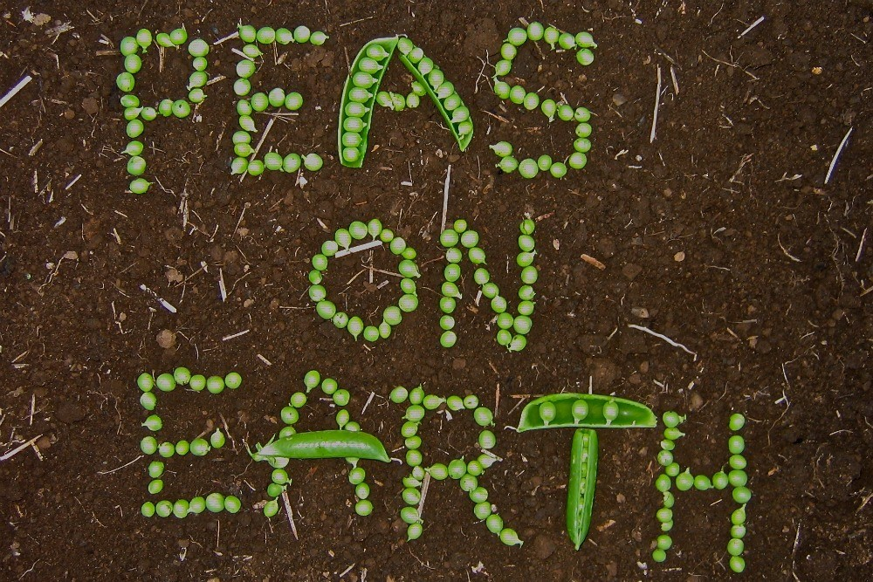

For more information or to book a school program: Rumbalara EEC, phone 4324 7200 or email: rumbalara-e.school@det.nsw.edu.au; or Lisa Wriley, phone or text 0429 431 889 or email: lisa.wriley2@det.nsw.edu.au – **HAPPY GARDENING!**

|  |
| --- |
| Fascinating Worm Facts |
| * Some earthworms consume their own weight in a combination of food, water and soil every day. * They pass the waste of that food from their bodies every 24 hours in the form of **vermicast** — natures best soil conditioner. * Under ideal conditions two mature worms can multiply to 1500 in a year. * A worm system 1 metre long by 2 metres by 30 centimetres deep can cope with the average **compostable** household waste for a year. * A well run worm system does not smell offensive. * Up to 70% of all household waste is edible by worms. * Worms normally live 2 to 3 years under favourable conditions, but healthy worms up to 15 years old have been recorded. * There are around 300 identified species native to Australia and nearly 200 native to New Zealand. * Worms have been around for 600 million years. * Worms mate only with worms of their own species. * Worm eggs — capsules — can survive drought and the coldest Australian and New Zealand winter, provided they are deep enough in the soil or itiswell mulched. * Worms detest light — two or more hours exposure to sunlight will kill them. * Cut a worm in half and it generally dies. You don't get two worms. Sometimes if the cut is far enough back, the worm may grow a new tail. * Earthworms are hermaphrodites — each worm is both male and female. * Mature worms can fertilise or be fertilised. In some cases they may do without a partner and self-fertilise. * Earthworms have no known diseases. * Earthworms do not have eyes. * Earthworms have five pairs of hearts. * Earthworms do not have any teeth – they have a gizzard where their food is ground up before being digested. * Earthworms breathe through their skin.   From a variety of sources |

# 

|  |  |
| --- | --- |
| **EARTHWORM QUIZ** Answer true (T), false (F) or unsure (U)  Worms have eyes T F U  Worms eat plastic T F U  Worms breathe through their skin T F U  Worms have 5 pairs of hearts T F U  Worms love sunlight T F U  Worms need a moist home T F U  Worms eat about half their own body  weight in food each day T F U  Each worm is both male and female T F U  If a worm is cut in the right place you will  get two worms T F U  Worms grind up food in their gizzard T F U  Worms have no known diseases T F U  Worms are cool T F U | **EARTHWORM QUIZ** Answer true (T), false (F) or unsure (U)  Worms have eyes T F U  Worms eat plastic T F U  Worms breathe through their skin T F U  Worms have 5 pairs of hearts T F U  Worms love sunlight T F U  Worms need a moist home T F U  Worms eat about half their own body  weight in food each day T F U  Each worm is both male and female T F U  If a worm is cut in the right place you will  get two worms T F U  Worms grind up food in their gizzard T F U  Worms have no known diseases T F U  Worms are cool T F U |
| **EARTHWORM QUIZ** Answer true (T), false (F) or unsure (U)  Worms have eyes T F U  Worms eat plastic T F U  Worms breathe through their skin T F U  Worms have 5 pairs of hearts T F U  Worms love sunlight T F U  Worms need a moist home T F U  Worms eat about half their own body  weight in food each day T F U  Each worm is both male and female T F U  If a worm is cut in the right place you will  get two worms T F U  Worms grind up food in their gizzard T F U  Worms have no known diseases T F U  Worms are cool T F U | **EARTHWORM QUIZ** Answer true (T), false (F) or unsure (U)  Worms have eyes T F U  Worms eat plastic T F U  Worms breathe through their skin T F U  Worms have 5 pairs of hearts T F U  Worms love sunlight T F U  Worms need a moist home T F U  Worms eat about half their own body  weight in food each day T F U  Each worm is both male and female T F U  If a worm is cut in the right place you will  get two worms T F U  Worms grind up food in their gizzard T F U  Worms have no known diseases T F U  Worms are cool T F U |
| **EARTHWORM QUIZ** Answer true (T), false (F) or unsure (U)  Worms have eyes T F U  Worms eat plastic T F U  Worms breathe through their skin T F U  Worms have 5 pairs of hearts T F U  Worms love sunlight T F U  Worms need a moist home T F U  Worms eat about half their own body  weight in food each day T F U  Each worm is both male and female T F U  If a worm is cut in the right place you will  get two worms T F U  Worms grind up food in their gizzard T F U  Worms have no known diseases T F U  Worms are cool T F U | **EARTHWORM QUIZ** Answer true (T), false (F) or unsure (U)  Worms have eyes T F U  Worms eat plastic T F U  Worms breathe through their skin T F U  Worms have 5 pairs of hearts T F U  Worms love sunlight T F U  Worms need a moist home T F U  Worms eat about half their own body  weight in food each day T F U  Each worm is both male and female T F U  If a worm is cut in the right place you will  get two worms T F U  Worms grind up food in their gizzard T F U  Worms have no known diseases T F U  Worms are cool T F U |

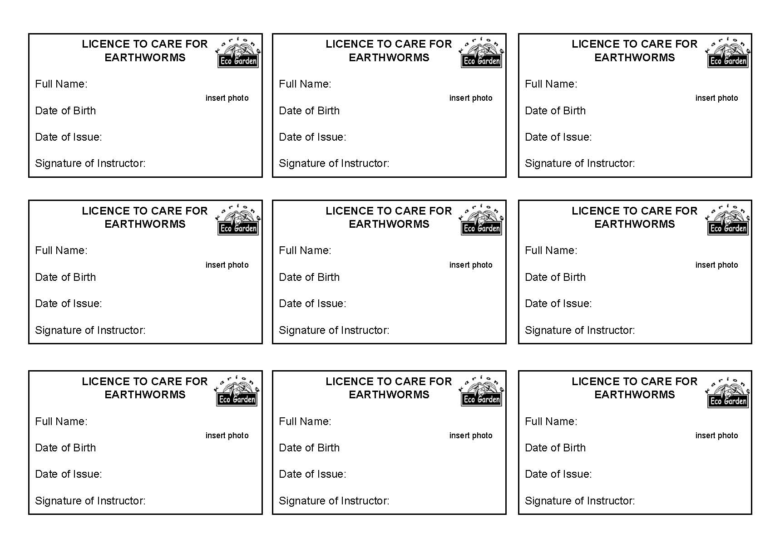

|  |
| --- |
| Worm Tub Do’s and Don’ts |
| **Do:**   * Visit your worms at least once a week * Feed your worms regularly: a varied diet will produce better castings. * Chop up food scraps: this speeds up the process as there is more surface area. (the worms are actually eating the bacteria that is eating the food) * Keep worm tub moist. * Cover worm bedding with hessian or cardboard. * Empty liquid fertiliser regularly and feed your plants with it. * Give worms away to others who want to start a worm farm. * Enjoy worm farming knowing that you are reducing waste going to landfill and thus reducing methane gas emissions. * Secure the lid with latch, wire or cord.   **Don’t:**   * Over feed your worms – add new food when they have eaten most of the last food you gave them. * Make the worm bedding too acidic – citrus and onion scraps are best recycled in a compost system where creatures are free to come and go. * Let worm tub dry out or become water logged. * Leave the lid open – birds will feast on your worms and food (so might mice and rats!)   This information is an excerpt from Kariong Eco Garden’s booklet – “Let worms wriggle into your life” |



|  |
| --- |
| Nature’s Recyclers – Teacher’s Notes |
| **Key Message** |
| Composting organic waste is an important way of contributing to a more sustainable pattern of living. Composting and worm farming is working with nature. In nature, nothing is wasted |
| **Curriculum Links – NSW** |
| * This program explicitly teaches SCIENCE Stage 2     **A student:**  **ST2-2VA** demonstrates a willingness to engage responsibly with local, national and global issues relevant to their lives, and to shaping sustainable futures.  **ST2-4WS** investigates their questions and predictions by analysing collected data, suggesting explanations for their findings, and communicating and reflecting on the processes undertaken  **ST2-10LW** describes that living things have life cycles, can be distinguished from non-living things and grouped, based on their observable features  **ST2-11LW** describes ways that science knowledge helps people understand the effect of their actions on the environment and on the survival of living things.   * This program supports parts of the GEOGRAPHY Stage 2   **A student:**  **GE2-2** describes the ways people, places and environments interact. Students investigate sustainable practices that protect environments e.g. discussion of ways waste can be managed sustainably   * This program supports parts of PDHPE Stage 2:   **PD2-6 -** describes how contextual factors are interrelated and how they influence health, safety, wellbeing and participation in physical activity  **PD2-7 -** describes strategies to make home and school healthy, safe and physically active spaces |
| **Cross Curriculum Priorities** |
| 1. Sustainability 2. Civics and Citizenship |
| **Background Information** |
| Organic matter and food scraps make up about half of the garbage put out by many households. This represents a significant amount of waste that could be returned safely to the earth, increasing soil fertility and reducing greenhouse gas emissions (mostly methane). Composting is the natural process of breaking down food scraps and garden waste into humus, a rich living soil that can be used in the garden to grow healthy plants.  People can compost using compost bins or compost heaps.  Composting organic matter allows the materials to complete their natural process by decomposing and regenerating the soil. The dead plant and animal tissues are broken down by living organisms in the soil.  Under a microscope, soil is full of tiny organisms including bacteria, fungi, nematodes, mites and springtails. Larger helpers in the compost heap include earthworms, ground beetles, wolf spiders, centipedes and slaters. Invertebrates are a vital part of ecosystems because of their number, variety and their influence on larger animals and plants and even entire ecosystems.  A handful of healthy soil or compost is full of life – in fact there are more micro-organisms in a handful of soil than there are humans on the earth (that is more than 7 billion!!).  When organic matter such as food scraps or plant material is buried in a landfill, instead or breaking down into rich humus, it ferments and produces a gas called methane (this is what makes landfill sites smelly). Methane is a really powerful greenhouse gas and therefore very harmful to our environment. We need to avoid making methane as much as we can. |
| **Learning Activities** |
| Today students will be examining the creatures that live in the compost and discover their role in nature’s system of returning nutrients to the environment. They will also be learning why composting, or recycling organic material, is a sustainable living practice. |
| * 1. **Compost Creature Poster** |
| Students are invited to examine the Gould League Compost Creatures poster. Student’s prior knowledge is sought.    **Focus questions:**  i) Does anyone have compost at home?  ii) **Is there a compost heap or bin at your school?**  iii) **What things can go in the compost?**  iv) **What things shouldn’t go into a compost heap? (bread, meat & dairy)**  v) Can you predict what kinds of invertebrates you will find in compost?  vi) What invertebrates do you think should not be in compost?  vii) **The invertebrates and other animals found in compost are called decomposers. What does this mean and what function do they have in compost?**  Look at page 13 in the Wise about Waste booklet to see some of the creatures we might find in the compost today. |
| **2. Compost Creature Investigation** |
| Students will be conducting an investigation to see what they can find in the compost.  Trays of compost, hand magnifying lenses, labelled cubes and utensils are provided. Students will need their booklet and a pencil to make a tally of the creatures they find.  “We will be using hand tools and magnifying lens’ to investigate the creatures in the compost.  Most compost creatures are harmless to humans. One dangerous spider that likes black compost bins and worm farms is red back spiders - do not touch these.  (An adult may safely remove or squash red back spiders as a bite to a child may require hospitalisation – after first aid treatment of applying ice).  If you would like to handle an earthworm this perfectly safe for you but to be kinder to the earthworms, you need to wet your hands. This is because our hands naturally have acid on them – which we can’t feel but the worm can. At the end it is important that everyone washes their hands.”  ***Code for Caring for Compost Creatures [to be displayed]***  1) Leave all dangerous small animals alone eg red back spiders.  2) Wet your hands if you want to handle an earthworm  3) Use utensils carefully to avoid crushing small animals.  4) When observing compost creatures, you may put them in a labelled container and after a short time return the animal to where it was found.  ***Note:*** *If students handle snails, slugs or their slime, ensure they keep their hands away from their mouths and wash their hands with soap afterwards*  *In your Wise about Waste Booklet:*   * Do a tally next to each creature to show how many you found * Which were the most common? Which were the least common? * How many different types of creatures were found? |
| **3. The Mechanics of Organics and Worm Menus** |
| Read Kellie Bollard’s book The Mechanics of Organics.  What things do worms eat? What things don’t they eat?  Look at Worm Food poster and plan to make a worm menu to display at school. |



|  |
| --- |
| **To Simplify** |
| **1. Look at Compost Creature poster and discuss.** |
| **Going Further** |
| Using the information on the back of the Compost Creatures Poster, create a food web. Who eats who?  • Lifecycle of an earth worm – draw the stages of an earthworm life – from egg sac to young worm (pre-breeding age), to mature worm (with visible clitellum/saddle).  • Discuss with students some examples of structural features and adaptations that may help animals to survive in a compost bin.  • Eg. An earthworm has a long, thin and flexible body which helps the earthworm to burrow between the soil particles to reach food and to escape from predators. Can students think of any other examples?  • Discuss with students some examples of adaptations (inherited physical features and behaviours that might help animals survive in a particular environment) of creatures in a compost bin.  • Eg. Springtails are tiny little creatures which are blind, almost colourless and have short legs. They scurry around in the compost in search of food. Their physical features help them to move around easily between the soil particles and to avoid predators. If uncovered, they quickly move under the soil particles. This behaviour would help them to survive by reducing their chances of drying out or being seen by predators. Can students think of any other examples? |
| **Sources** |
| 1) Down to Earth : An Earth Works learners guide / NSW EPA, Environment Protection Authority.  2) Earthworks Course Participants Notes (NSW EPA).  3) Compost Creatures Poster (Gould League). |
| **Resources** |
| 1) Worm Farm cross section model  2) Gould League Compost Creatures poster  3) Bucket of living compost  4) ID charts  5) Plastic sheeting to spread on table or ground  6) Magnifying lens’  7) Plastic utensils for gently moving soil and creatures  8) Hand-washing bucket and soap  9) Dustpan and brush for clean up  10) Book: The Mechanics of Organics by Kellie Bollard  11) Poster: Worm Food by Kellie Bollard |

Notes: